How to Crack Word Password with word password cracker
Article Source:
http://recoverlostpassword.com/article/crack-word-password-with-word-password-cracker.html
I am an administrative assistant. Yesterday I received some assignments from my boss. Unfortunately, all of the files were password protected read-only word files and I can’t open either of them. What’s more, my boss is now on a business trip and I can’t contact him to unlock the word files for me or ask him to send me the unprotected versions instead. I need these word files in emergency, I have no idea on how to crack word password, and also don’t have any idea about the legal situation in the context of the cracking process.
Is it legal to crack password protected Word files?
Everyone feel it is illegal to crack password protected Word files, you can go shopping instead. I think the process of cracking word password is not illegal since it is a document that your boss sent you and you have to complete the process in many cases other than doing it with a bad intention. Sometimes locked word files need to be cracked for a lawful purpose, so, cracking the secured word files sent by your boss is a legal operation.

Don’t think that only crackers can open the password protected word document. Cracking password protected word files is no so miraculous. Everyone can be a cracker if you own a word cracker. The word password crackers are software designed to recover the passwords which you have forgotten or need to obtain for performing important jobs. This is absolutely legal.
Here is how you can crack the password protected word document:
Suppose you have word file named as mydocument.doc. Firstly, open the document and click the Save As option to save it as an RTF (Rich Text Format) file. The file will end up being named as mydocument.rtf. Open the RTF file you have just saved by double-clicking it. Then the next step is save the RTF file as a MS Word format file. That is all, you have cracked the password protected word files and you can do your job now.
You can also break the password using the directions of word password cracker software.

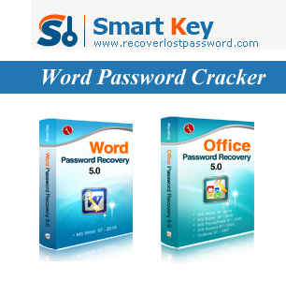
Word Password Recovery
Word Password Recovery software is a new revolutionary solution for cracking word password while lost or forgot MS Word document password, it can help you easily recover or restore password protected dock file/forgotten word document password to open and modify. It supports all MS word document encryption algorithms.
Office Password Recovery
Office Password Recovery is an "all-in-one" solution for recovery all types password of Microsoft Office applications password, including MS Word document, MS Excel spreadsheets, MS Access databases, MS PowerPoint presentations. It also supports all versions of Microsoft Office, including 2007.
If you think that cracking word password is an illegal job and would like to wait for the return of your boss, i have to say you are so stupid as your time have been wasted. Your boss would also not be appreciating with your behavior. So, quickly follow my procedure to crack word password.

